SECTION B - PLANNING AND DESIGN



Group Members: | 1: Keabetswe Ramahlape Malwa – ST10442089  2: Seabelo Motloung - ST10447004  3: Sheketli Mochaki - ST10452756  4: Gladwin Engetani Nkuna – ST10438545  5: Mothoka Malatji - ST10439690
Assessment Type | Group Project - Part 1
Module | OPSC6312 - Open Source Coding (Intermediate)
Institution | The IIE / Rosebank College
Submission Date | 24 August 2026

1. Introduction
The planning and design phase converts the research findings into a development blueprint for Pokémon Explorer. The app will be an Android application written in Kotlin and developed in Android Studio. It will consume PokéAPI v2 through RESTful HTTPS requests and store user-specific data locally. The plan defines the scope, requirements, user interface, navigation, API integration, local database, data types, architecture and a Microsoft Project schedule before Part 2 implementation begins.

2. Application overview
Pokémon Explorer
Tagline: Discover. Compare. Explore.
Purpose: A focused Android Pokédex-style explorer that retrieves Pokémon information from PokéAPI and allows users to save favourites, track caught Pokémon, compare statistics and discover random Pokémon.

2.1 Innovative features
Feature | Behaviour | Why it adds value
Pokémon Compare | Select two Pokémon and compare HP, Attack, Defense, Special Attack, Special Defense and Speed side-by-side. | Avoids repeatedly switching between separate profiles.
Random Discovery | Generate a valid random Pokémon and open its profile. | Encourages exploration even when the user does not know what to search for.
Shiny Toggle | Switch between normal and shiny sprite/artwork when available from PokéAPI. | Adds a Pokémon-specific visual interaction using data already exposed by the API.
Personal Pokédex | Allow an authenticated user to mark Pokémon as Favourite and/or Caught and track collection progress. | Creates persistent personal value by allowing each user to maintain their own Pokémon collection information.
Type Guide | Show damage relationships for a selected type. | Extends the app beyond static facts into useful battle-oriented reference information.

3. Detailed application requirements
What We’re Building
Pokémon Explorer isn’t just another Pokédex—it’s a handy, fast, and fun way for users to browse, search, and learn about their favorite Pokémon. This document spells out exactly what the app needs to do when we build it, so there’s no guesswork later.
These requirements come from two places:
- The core features we discovered during our research (the stuff users actually want).
- The must-have technical checkboxes for Part 2 (the stuff that keeps the grading rubric happy).
Every requirement below includes:
- What success looks like – so we know when we’re done.
- Why it matters – so we don’t just build for the sake of building.
ID | What we need | How we’ll know it works | Why we’re doing it
FR01 | Connect to the PokéAPI v2 using Retrofit and OkHttp over HTTPS. | The app fetches data successfully, parses it, and shows it without crashing – even if the network is slow or flaky. | This is the backbone of the whole app. Without it, we have no Pokémon data.
FR02 | Browse Pokémon in pages, showing name, Pokédex number, image, and type(s). | Users can scroll through a list of Pokémon and see the key info at a glance – no search needed. | Not everyone knows what they're looking for. Browsing makes exploration easy and fun.
FR03 | Search for a Pokémon by name or Pokédex number. | Typing a name or number instantly filters the list. If nothing matches, we show a clear "no results" message. | When you know what you want, you don't want to scroll – you want to get there fast.
FR04 | Show a detailed screen with ID, name, official artwork, types, height, weight, abilities, base stats, and a reasonable set of moves. | Tapping any Pokémon opens a full profile with all the classic Pokédex info a fan would expect. | This is the heart of the experience – the "wow" moment when you really get to know a Pokémon.
FR05 | Filter the Pokémon list by type and by generation. | Users can pick a type (like Fire) or a generation (like Gen 1) and see only matching Pokémon. | With 800+ Pokémon, filters turn a wall of names into a manageable, meaningful list.
FR06 | Let new users create a local account with valid details, and keep that account saved after the app restarts. | A user registers once, closes the app, reopens it, and can still log in with the same credentials. | This is a mandatory feature for Part 2, and it gives users their own personalised space.
FR07 | Allow registered users to log in with their credentials – but never store plaintext passwords. Use salted hashing (or another approved method) instead. | Passwords are stored securely. Even if someone gets into the database, they can't read real passwords. | We take security seriously. No excuses – plaintext passwords are a hard no.
FR08 | Let logged-in users mark Pokémon as Favourites, and remember that choice even after the app closes. | Tapping the heart (or star) toggles favourite status, and it stays that way when you come back later. | Favourites give users quick access to their top picks and make the app feel personal.
FR09 | Let users mark Pokémon as "Caught" or "Not Caught" and show overall collection progress. | Users can track which Pokémon they've caught, see a progress bar or counter, and update it anytime. | This taps into the collector mindset – one of the strongest user needs we found in research.
FR10 | When marking a Pokémon as caught, optionally record the current GPS location. If location permission is denied or GPS is off, the rest of the app still works perfectly. | The location saves when available, but the app never forces it. No crashes, no blocking – just a helpful extra. | We show we can use device hardware, but we don't punish users who say "no" to location.
FR11 | Let users pick any two Pokémon and compare their HP, Attack, Defense, Special Attack, Special Defense, and Speed side by side. | A compare screen shows both Pokémon with their stats lined up clearly, making differences obvious. | Our research showed that fans love debating stats – this gives them a fair, quick way to do it.
FR12 | Pick a random Pokémon and open its details screen when the user asks for it. | One tap = one random Pokémon, every time. No repeats forced, but no duplicate blocking either – just fun randomness. | Perfect for when you're bored or indecisive. It turns the app into a discovery machine.
FR13 | On the details screen, let users toggle between normal and shiny artwork whenever shiny art is available from the API. | A button or switch flips the sprite between normal and shiny. If shiny isn't there, the toggle is hidden or disabled. | Shiny hunters will love this. It's a small detail that makes the app feel alive and interactive.
FR14 | Show type strengths, weaknesses, and resistances using data from the PokéAPI type endpoint. | Users can look up any type and see what it's strong against, weak to, and resistant to – all pulled live from the API. | This turns the app from a simple viewer into a useful battle-reference tool.
FR15 | Use Room to store authentication info, favourites, caught records, catch locations, search history, and cached Pokémon data. | All this data survives app restarts and is structured properly in a local database. | Room gives us reliable, structured storage – and it's a mandatory part of the tech stack.
FR16 | Keep cached Pokémon info and local collection data available even when the internet is down. | Users can still browse previously viewed Pokémon, see their favourites, and check caught status offline. | Nobody likes an app that dies when Wi-Fi drops. This keeps things useful in real-world scenarios.
FR17 | Use WorkManager and connectivity monitoring to refresh data automatically when the internet comes back online. | If a request fails due to no connection, the app retries it later when Wi-Fi or data returns – without user intervention. | This makes the app feel smart and resilient, and it satisfies the sync requirement cleanly.
FR18 | Use DataStore for lightweight settings like theme, language, notification preference, and reset options. | Changing a setting persists immediately and survives restarts – separately from the heavier Room data. | Not everything needs a full database. DataStore keeps settings simple and fast.
FR19 | Receive and display push notifications via Firebase Cloud Messaging (or another approved service). | Notifications arrive on the device and appear in the system tray. If the user has disabled notifications in settings, we respect that. | Push notifications are a required capability – and they add real value for future features like "Pokémon of the day."
FR20 | Support at least English and isiZulu using Android string resources, and let users pick their language in Settings. | Switching the language changes the UI text immediately (or after restart) – no hardcoded strings anywhere. | This proves we can build a multilingual app – and it makes the app more inclusive.
FR21 | Show clear loading, empty, and error states throughout the UI. Network errors, invalid searches, missing images, or permission denials must never crash the app. | Users see a spinner while loading, a friendly "nothing here" message when empty, and a helpful error message when something goes wrong – never a force-close. | Crashes ruin trust. Good state handling keeps the app reliable and user-friendly.
FR22 | Write unit and/or integration tests for repositories, ViewModels, authentication, persistence, network logic, and other key parts of the app. | Tests run successfully and catch regressions. Key logic is verified, not just manually clicked through. | Testing proves we care about quality. It also saves us from nasty surprises later.
FR23 | Set up GitHub Actions to run the full test suite on every push and pull request – and fail the build if any required test fails. | The CI pipeline runs automatically, and the team gets immediate feedback on whether changes broke anything. | Continuous integration keeps us honest. It's our safety net and our proof that the app stays testable.
FR24 | Deliver a final release-ready build with an app icon, version metadata, responsive layouts, and no known critical defects. | The app looks polished on different screen sizes, has proper versioning, and passes a final sanity check without major bugs. | This is our final hand-in. It needs to look and feel like a real, shippable product – not a rough prototype.

3.1 Non-functional requirements
ID | What we're committing to | How we'll design it | Why it matters to users (and us)
NFR01 | Performance – The app feels fast and responsive, even with hundreds of Pokémon. | We'll use pagination so we only load one "page" of Pokémon at a time. Lazy lists (like LazyColumn) will render only what's visible on screen. All network calls happen off the main thread, and we'll cache responses locally so repeat views are instant. | Nobody likes waiting. This keeps scrolling buttery smooth and saves the user's data plan too.
NFR02 | Reliability – The app doesn't crash – ever – even when things go wrong. | We'll explicitly handle timeouts, HTTP errors (like 404 or 500), invalid searches, missing API fields, permission denials, and local database failures. Every error path shows a friendly message instead of a white screen or force-close. | Crashes break trust. Users should feel like the app has their back, even when the network or API lets us down.
NFR03 | Maintainability – Clean, separated code that we (and future devs) can actually work with. | We'll follow a clear architecture: UI layer (Compose/Activities), ViewModel + State hoisting, Repository pattern, and separate Remote (Retrofit) and Local (Room) data sources. Each piece has one job. | Spaghetti code is a nightmare to debug or extend. This keeps us sane now, and makes Part 3 (or a future intern) much less painful.
NFR04 | Usability – Core features are intuitive and give clear feedback. | Key actions (browse, search, view details, favourite, catch) are reachable in 2–3 taps max. Buttons and links use plain, familiar language. Loading spinners, success toasts, and error messages appear for every user action. | Users shouldn't need a manual. If they have to guess what a button does, we've already lost them.
NFR05 | Accessibility – Everyone can use the app, regardless of ability. | We'll use readable font sizes, high-contrast colour combinations, and tap targets that are at least 48dp tall/wide. Every meaningful icon and image will have a content description for screen readers. | Accessibility isn't a "nice to have" – it's about making sure the app works for all users, including those with visual or motor impairments.
NFR06 | Security – User data stays private, and we don't cut corners. | All API communication uses HTTPS (no plain HTTP). Passwords are salted and hashed before they ever touch disk – never stored as plaintext. Any API keys or sensitive config values are kept out of public source control (using local.properties or environment variables). | We're handling real user credentials. Storing passwords in plaintext is inexcusable – and we'd fail the assessment (and our own ethics) if we did.
NFR07 | Responsiveness – The UI adapts gracefully to different phones and orientations. | Layouts use flexible units (dp, wrap_content, ConstraintLayout/Compose modifiers) and handle orientation changes without losing state. We'll test on multiple screen sizes (small phones, large phones, tablets if time allows). | A UI that breaks on a Pixel 8 but works on a Galaxy S21 is a UI that's not finished. Users expect their phone to just work.
NFR08 | Offline Behaviour – The app stays useful when the internet drops. | Cached Pokémon data and locally stored collections (favourites, caught status, locations) remain fully viewable and editable offline. When the network comes back, we use WorkManager to sync deferred tasks predictably – no duplicate data, no lost changes. | Real life isn't always online. Users on trains, in basements, or with spotty coverage shouldn't be locked out of their own collection.

4. User-interface design and navigation

Pokémon Explorer uses five primary screens: Home / Explore, My Collection, Compare Pokémon, Type Guide and Settings. The interface is intentionally organised around a small number of multifunctional screens so that users can access important functions without unnecessary navigation. Supporting interactions such as authentication, detailed Pokémon information, GPS permission requests and confirmation messages are presented through contextual actions, dialogs or expandable content rather than separate primary screens.

The mockups illustrate the intended layout, information hierarchy and navigation of the application. Exact colours, typography and spacing may be refined during implementation while maintaining the planned functionality and navigation structure.

The visual design uses a Pokémon-inspired interface while prioritising readability, sufficient contrast, accessible touch targets and straightforward navigation.

4.1 Home / Explore
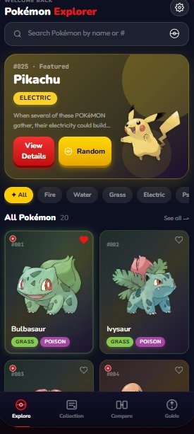 | Purpose  The primary Pokémon discovery screen. Users can browse Pokémon, search by name or Pokédex number, apply type/generation filters, use Random Discovery and select a Pokémon to view more detailed information.  Main functionality:  - Browse Pokémon  - Search  - Type/generation filtering  - Random Discovery  - Pokémon artwork and basic information  - Detailed Pokémon information when selected  - Favourite action  - Mark as Caught action  - Shiny Toggle where available  Primary navigation  Opens My Collection, Compare Pokémon, Type Guide and Settings. Selecting a Pokémon displays its detailed information without requiring a separate primary navigation screen.

4.2 My Collection

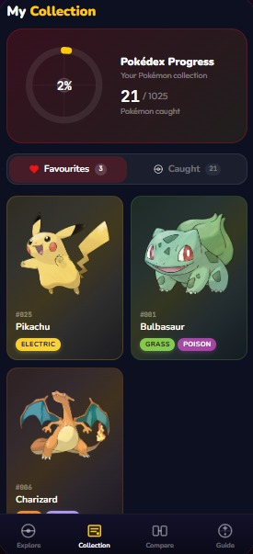 | Purpose  Contains Favourite and Caught views plus a simple collection-progress indicator.  Main functionality:  - Favourite Pokémon  - Caught Pokémon  - Collection progress  - Date caught where available  - Optional stored catch location  When a Pokémon is marked as caught, the user may optionally allow Pokémon Explorer to record the device's current GPS location. Location permission denial will not prevent the rest of the application from functioning.  Primary navigation  Selecting a Pokémon returns the user to its detailed information in Home / Explore.

4.3 Compare Pokemon
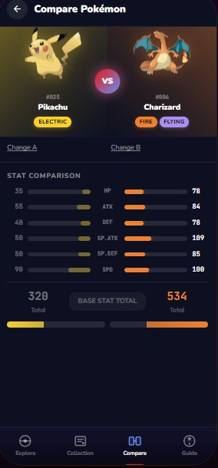 | Purpose  Allows the user to select two Pokémon and compare their HP, Attack, Defense, Special Attack, Special Defense and Speed side-by-side.  Primary navigation  Users can change either selected Pokémon or return to Home / Explore.

4.4 Type Guide
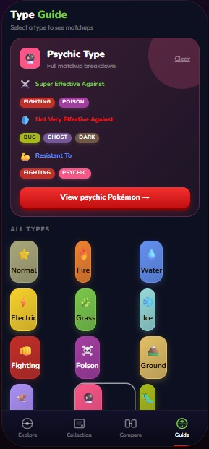 | Purpose  Displays type matchup information including strengths, weaknesses and resistances using information retrieved from PokéAPI.  Primary navigation  The user can return to Home / Explore or display Pokémon belonging to the selected type.

4.5 Settings
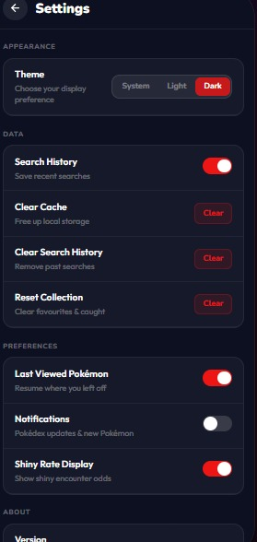 | Purpose  Stores theme and data-management preferences and provides clear/reset actions.  Primary navigation  Return to previous screen; changes apply immediately.

4.9 Navigation diagram
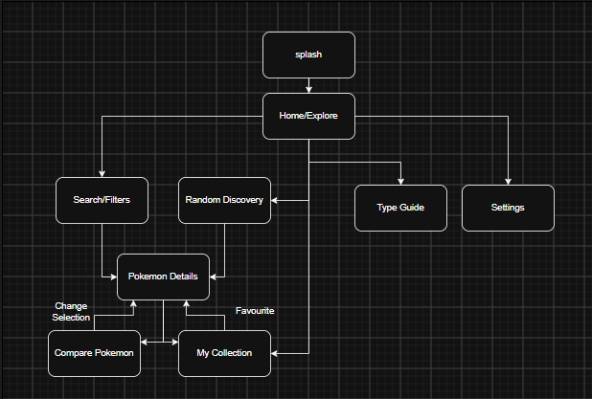
From Home / Explore, the user can navigate to:
- Search / Filters
- Pokémon Details
- My Collection
- Compare Pokémon
- Type Guide
- Settings
- Random Discovery
Search / Filters → Pokémon Details
Random Discovery → Pokémon Details
My Collection → Pokémon Details
Pokémon Details → Compare Pokémon
Pokémon Details → Favourite / Caught actions
Type Guide
Settings
The navigation should allow users to return to the previous screen using normal Android navigation behaviour.

5. RESTful API design
An existing API has been selected, so the project will not create or host a new server-side API for Part 2. Pokémon Explorer will use the public PokéAPI v2 base address, https://pokeapi.co/api/v2/. The Android client will issue RESTful HTTPS GET requests through Retrofit/OkHttp and receive JSON responses. This approach directly satisfies the brief requirement to state how the API is created/hosted or, where an existing API is selected, how it will be used.
PokéAPI is used as a read-only external Pokémon information source and does not receive personal Pokémon Explorer user information. Authentication information, Favourite records, Caught records, catch-location information and search history are stored locally using Room. Lightweight preferences such as theme, selected language and notification settings are stored using DataStore. WorkManager and connectivity monitoring are used for reconnect and background refresh behaviour. Firebase Cloud Messaging, or an approved equivalent, is used separately for push notifications. Therefore, synchronisation in Pokémon Explorer mainly refers to refreshing cached remote information and completing deferred reconnect work rather than uploading personal collection information to PokéAPI.

5.1 API endpoints and data flow
Use case | Request | Main response data used
Browse | GET /pokemon?limit=20&offset={n} | name + resource URL; detail requests are loaded only when required
Search / Details | GET /pokemon/{id-or-name} | id, name, height, weight, abilities, moves, sprites, stats, types, species
Species information | GET /pokemon-species/{id-or-name} | species information and generation-related references where required
Type Guide | GET /type/{id-or-name} | damage_relations and Pokémon references for the selected type
Generation filter | GET /generation/{id-or-name} | generation metadata and species references

PokéAPI documents the Pokémon resource as containing fields including id, name, height, weight, abilities, moves, sprites, species, stats and types. Height is returned in decimetres and weight in hectograms, so the UI layer will convert these to metres and kilograms for display (PokéAPI, 2026).

5.2 Request lifecycle
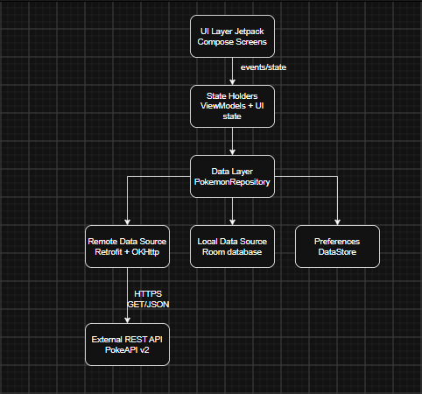
Android guidance recommends separating the UI layer from the data layer and using repositories to centralise data access. Pokémon Explorer follows that recommendation: composables render immutable UI state; ViewModels coordinate user events; the repository chooses between remote PokéAPI data, the Room cache and lightweight preferences (Google, 2026a).

6. Local database and persistence design
Room will be used instead of directly accessing SQLite. Android documentation describes Room as an abstraction layer over SQLite that provides compile-time SQL verification, convenient annotations and migration support. It is also appropriate for caching relevant data so content can remain available when the network is unavailable (Google, 2026b).
The app will not download and permanently duplicate the entire PokéAPI dataset. Instead, the repository will cache selected Pokémon after they are viewed, while favourites, caught status and search history remain authoritative local user data.

7. Entity Relationship Diagram

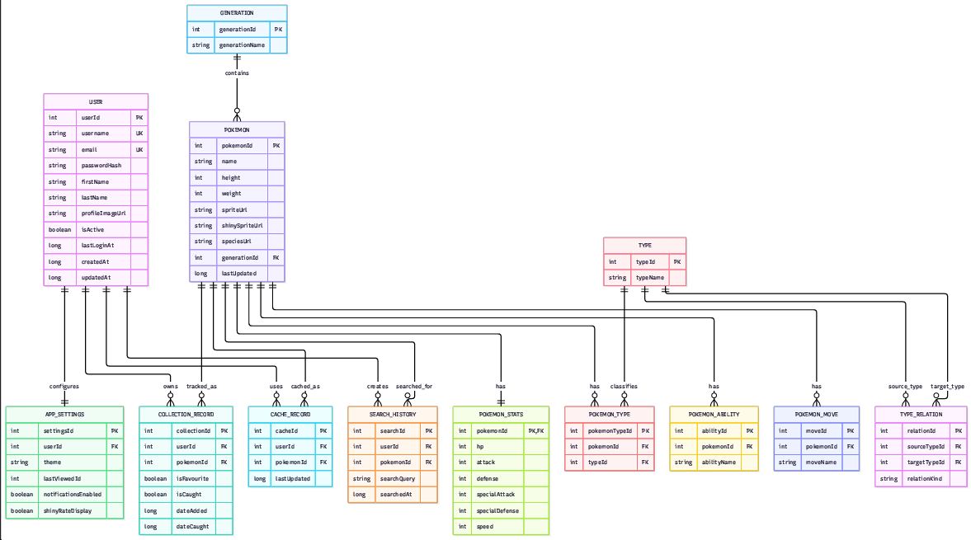
7.1 Entity Relationship Diagram

7.2 Component / API integration diagram
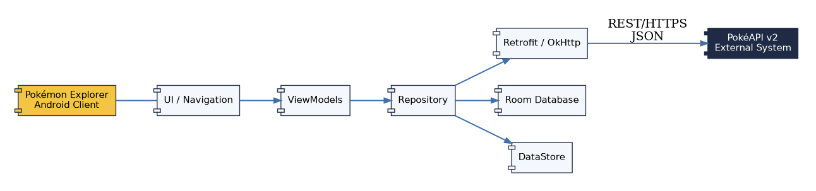

8. Detailed data requirements
The brief requires a detailed listing of information the application captures from the user and stores, including data types. The tables below separate external PokéAPI data from local user-created data.
Field | Kotlin type | Source / use
id | Int | PokéAPI Pokémon identifier and local cache key
name | String | Display/search name
height | Int | API value in decimetres; converted for UI
weight | Int | API value in hectograms; converted for UI
spriteUrl | String? | Default image URL
shinySpriteUrl | String? | Optional shiny image URL
types | List<String> | Type badges, filters and guide
abilities | List<String> | Details screen
moves | List<String> | Details screen; display a sensible subset
hp | Int | Base stat
attack | Int | Base stat
defense | Int | Base stat
specialAttack | Int | Base stat
specialDefense | Int | Base stat
speed | Int | Base stat
speciesUrl | String | Optional secondary API request
generation | String? | Generation filter / species metadata
Local field | Kotlin type | Captured from user / purpose
pokemonId | Int | Selected Pokémon identifier used by favourite/caught tables
isFavourite | Boolean | Set by Favourite button
isCaught | Boolean | Set by Caught toggle
dateAdded / dateCaught | Long / Long? | Timestamp for collection events
searchQuery | String | Text entered into the search field
searchedAt | Long | Timestamp for search history
theme | String / enum-like preference | Theme selected in Settings
lastViewedId | Int? | Optional convenience state
lastUpdated | Long | Cache freshness timestamp

9. Proposed Android technology stack
Technology | Purpose
Kotlin | Primary Android programming language
Android Studio | IDE and build environment
Jetpack Compose | Screen construction and adaptive UI
ViewModel + StateFlow | Screen state and event coordination
Retrofit + OkHttp | RESTful HTTP communication with PokéAPI
Kotlin Coroutines | Non-blocking asynchronous work
Room | Structured local database and cache
DataStore | Lightweight preferences
Coil | Remote Pokémon image loading/caching
JUnit / Android test tools | Automated tests
Git + GitHub | Version control and collaboration
GitHub Actions | Continuous integration and automatic test execution

Technology | Purpose
WorkManager | Background reconnect, retry and deferred synchronisation
Android Location APIs / Fused Location Provider | Optional GPS catch-location capture
Firebase Cloud Messaging | Push notifications
Android String Resources | English and isiZulu localisation
Secure hashing / lecturer-approved credential protection | Protect locally persisted passwords

10. Microsoft Project plan and Gantt chart
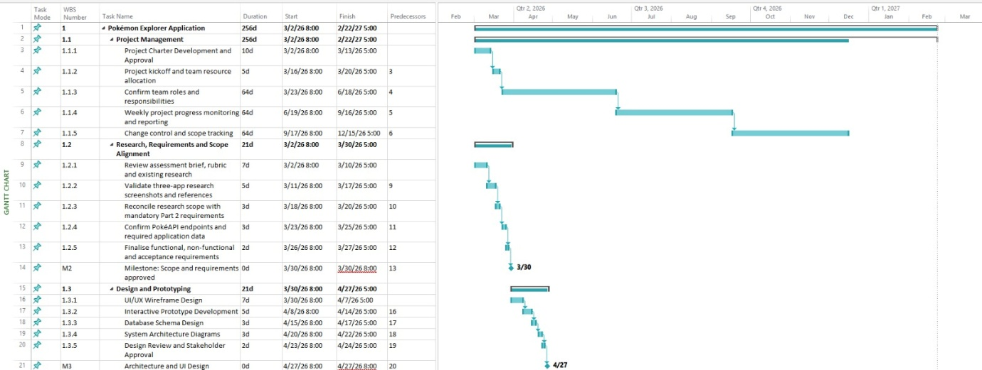
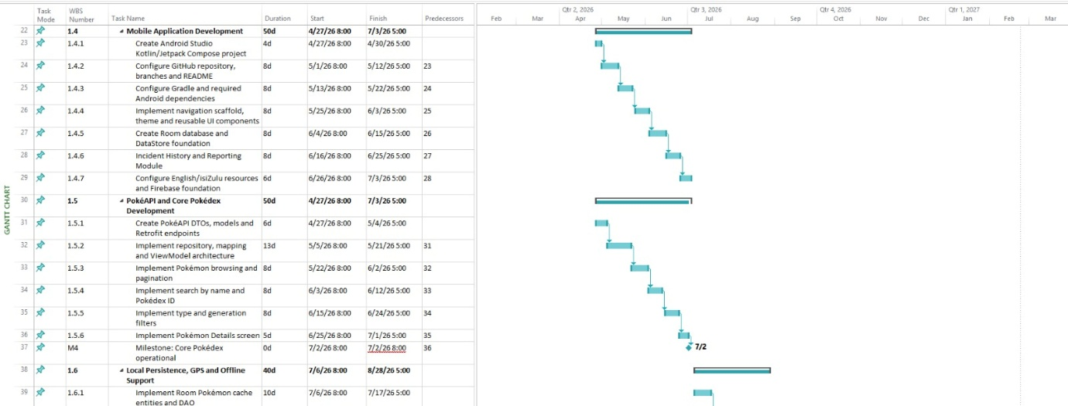
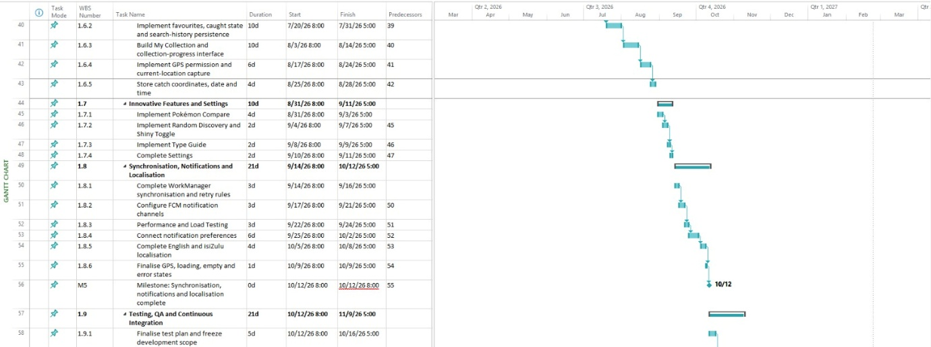
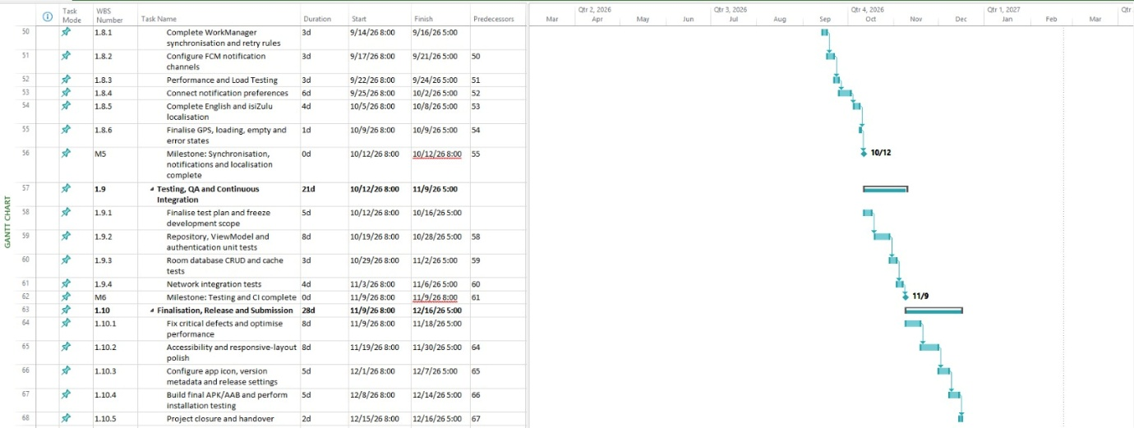

10.1 Project milestones
WBS | Milestone | Target date | Exit condition
1.6 | Project governance baseline established | 28 Aug 2026 | Team roles, responsibilities, risk register and governance approach established.
2.6 | Scope and requirements approved | 28 Aug 2026 | Research, mandatory requirements and PokéAPI scope aligned and approved.
3.8 | Design package complete | 4 Sep 2026 | Application mockups, navigation, UML diagrams, API integration design and data model complete.
4.8 | Android project foundation complete | 14 Sep 2026 | Kotlin/Compose project, GitHub repository, Room/DataStore, authentication and foundational configuration complete.
5.8 | Core Pokédex operational | 21 Sep 2026 | PokéAPI integration, browsing, search, filtering, Pokémon Details and network/error handling operational.
6.8 | Local collection, GPS and offline functionality complete | 28 Sep 2026 | Favourites, caught tracking, collection progress, GPS catch-location recording, Room caching and offline behaviour operational.
7.7 | Innovative features and Settings complete | 5 Oct 2026 | Pokémon Compare, Random Discovery, Shiny Toggle, Type Guide and Settings complete.
8.7 | Synchronisation, notifications and localisation complete | 12 Oct 2026 | Reconnect behaviour, push notifications and English/isiZulu localisation operational.
9.9 | Testing and CI complete | 15 Oct 2026 | Unit, database, network, UI/navigation, offline and integration testing complete, with GitHub Actions functioning.
10.8 | Pokémon Explorer final release candidate complete | 16 Oct 2026 | Critical defects resolved, documentation and evidence prepared and stable release candidate ready for assessment.

11. Testing and GitHub Actions plan
Testing is planned as part of development rather than as a final afterthought. The unit-test focus will be ViewModel state changes, repository mapping/decision logic and local persistence rules. Room database behaviour will be tested using Android-supported test approaches. Network tests will use a fake or mock HTTP layer so automated tests do not depend on live PokéAPI availability. Navigation and UI flows will be checked on representative Android screen sizes.
- Unit tests: repository mapping, random-ID boundaries, search validation, comparison calculations/state, favourites/caught state transformations.
- Database tests: insert/update/delete favourites and caught records, search-history persistence and cache refresh rules.
- Network integration tests: successful JSON parsing, 404 handling, timeout/error state mapping, null/optional sprite handling.
- UI/navigation tests: Browse -> Details, Details -> Compare, collection item -> Details, filters, loading/error states.
- GitHub Actions: checkout repository, set up JDK/Gradle, run unit tests, fail the workflow when tests fail.

12. Error-handling design
Condition | User message / behaviour
No internet connection | “We could not connect to PokéAPI. Check your connection and try again.” If cached data exists, offer the cached result.
Pokémon not found (404) | “No Pokémon was found with that name or Pokédex number.”
Empty search | “Enter a Pokémon name or Pokédex number.”
Timeout / server failure | “Pokémon information is temporarily unavailable. Please try again.”
Missing image | Show a neutral placeholder rather than breaking the layout.
Database failure | Keep the screen usable where possible and show a concise retry message for local actions.

13. Planning and design conclusion
The planning and design phase provides a complete blueprint for the Part 2 prototype. Pokémon Explorer has a deliberately controlled scope: it focuses on RESTful PokéAPI integration, readable Pokémon information, local persistence and a small set of original interactions. The design avoids cloud accounts, trading and commercial features that would add unnecessary risk to the assignment.
The proposed architecture follows Android’s recommended separation of UI and data responsibilities. Retrofit/OkHttp will handle REST communication, Room will provide structured local storage, DataStore will hold lightweight preferences and Coroutines will support asynchronous work. The mockups, navigation, UML, data tables and Microsoft Project plan give the implementation team a clear sequence of work and testable acceptance points.

14. Planning and design references
Google (2026a) Guide to app architecture. Android Developers. https://developer.android.com/topic/architecture
Google (2026b) Save data in a local database using Room. Android Developers. https://developer.android.com/training/data-storage/room
JetBrains (2026) Coroutines. Kotlin Documentation. https://kotlinlang.org/docs/coroutines-overview.html
PokéAPI (2026) PokéAPI v2 Documentation. https://pokeapi.co/docs/v2
Square (2026) Retrofit / Square Open Source. https://square.github.io/retrofit/

